> library(deSolve)
> library(dplyr)
> library(ggplot2)
> library(tidyr)
> library(purrr)
> library(ggpubr)
> sir <- function(time, stocks, auxs){
+ with(as.list(c(stocks, auxs)),{
+ N <- 10000 # Eq (11)
+ IR <- beta*I*S/N # Eq (9)
+ RR <- gamma*I # Eq (10)
+ dS_dt <- -IR # Eq (6)
+ dI_dt <- IR - RR # Eq (7)
+ dR_dt <- RR # Eq (8)
+ return (list(c(dS_dt,dI_dt,dR_dt),
+ Beta=beta,
+ Gamma=gamma,
+ Infections=IR,
+ Recovering=RR))
+ })
+ }
> simtime <- seq(0,50,by=0.25)
> stocks <- c(S=9999,I=1,R=0) # Eq (14), Eq (15), and Eq (16)
> auxs <- c(gamma=0.25,beta=1) # Eq (12) and Eq (13)
> res <- ode(y=stocks,
+ times=simtime,
+ func = sir,
+ parms=auxs,
+ method="euler") %>%
+ data.frame() %>%
+ dplyr::as_tibble()
> res
# A tibble: 201 × 8
time S I R Beta Gamma Infections Recovering
<dbl> <dbl> <dbl> <dbl> <dbl> <dbl> <dbl> <dbl>
1 0 9999 1 0 1 0.25 1.000 0.25
2 0.25 9999. 1.19 0.0625 1 0.25 1.19 0.297
3 0.5 9998. 1.41 0.137 1 0.25 1.41 0.353
4 0.75 9998. 1.67 0.225 1 0.25 1.67 0.419
5 1 9998. 1.99 0.329 1 0.25 1.99 0.497
6 1.25 9997. 2.36 0.454 1 0.25 2.36 0.590
7 1.5 9997. 2.80 0.601 1 0.25 2.80 0.701
8 1.75 9996. 3.33 0.777 1 0.25 3.33 0.832
9 2 9995. 3.95 0.985 1 0.25 3.95 0.988
10 2.25 9994. 4.69 1.23 1 0.25 4.69 1.17
# ℹ 191 more rows
# ℹ Use `print(n = ...)` to see more rows
> flows_piv <- res %>%
+ dplyr::select(time,Infections:Recovering) %>%
+ tidyr::pivot_longer(names_to="Flow",
+ values_to = "Value",
+ -time) %>%
+ dplyr::mutate(Flow=factor(Flow,
+ levels = c("Infections",
+ "Recovering")))
> stocks_piv <- res %>%
+ dplyr::select(time,S:R) %>%
+ tidyr::pivot_longer(names_to="Stock",
+ values_to = "Value",
+ -time) %>%
+ dplyr::mutate(Stock=factor(Stock,
+ levels = c("S","I","R")))
> p1 <- ggplot(flows_piv,aes(x=time,y=Value,color=Flow))+geom_line()+
+ theme(legend.position = "top")+
+ labs(x="Day",y="Flows")

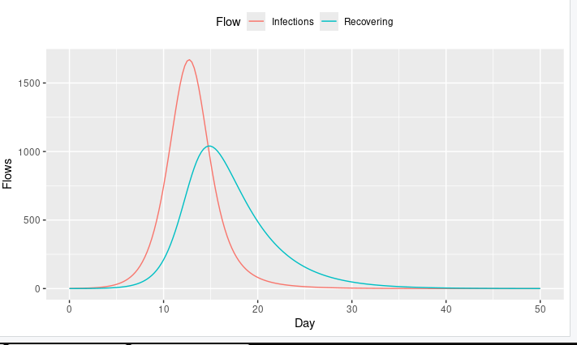

> p2 <- ggplot(stocks_piv,aes(x=time,y=Value,color=Stock))+geom_line()+
+ theme(legend.position = "top")+
+ labs(x="Day",y="Stocks")
>

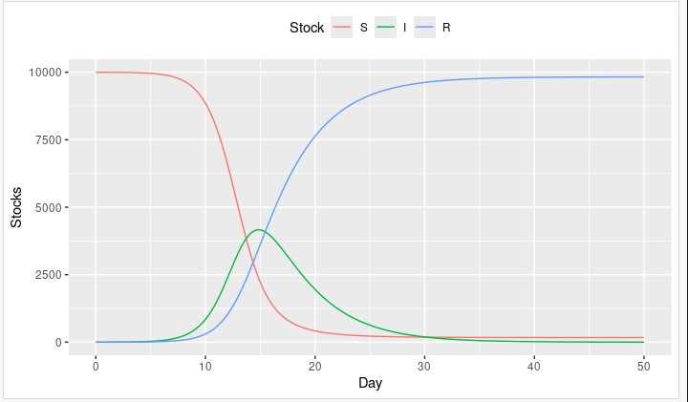
> g1 <- ggarrange(p1,p2,nrow = 2)
> g1

